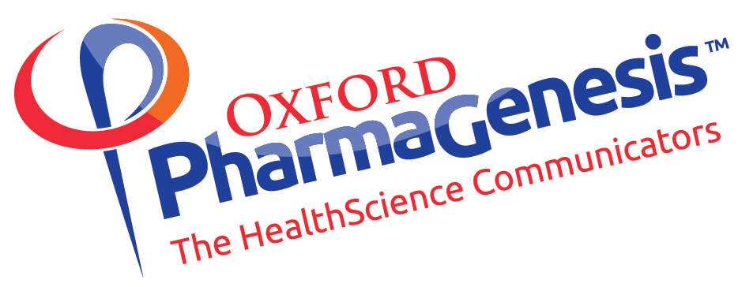

Innovation in scientific publishing
and the role of the pharmaceutical industry

Overview of an exploratory round-table meeting

09:00–16:00, Thursday 19 January 2017
Room 303, Wellcome Trust, Gibbs Building,
215 Euston Road, London, NW1 2BE

‘Is now the time to transform the model for dissemination of the findings of medical research funded by the pharmaceutical industry?’

‘Yes’

Introduction
Our group met to:
- understand current problems with publishing science
- review innovations and to discuss what more might be needed
- discuss whether the pharmaceutical industry might have a role in encouraging innovation, and if we think that there is such a role, to discuss what it might be and agree next steps.

Key points from the presentations

Academic perspective
- There is pressure to publish a high volume of research papers in journals with a high impact factor.
- Although it is widely recognised that using the impact factor of a journal as a surrogate for the impact of a paper published in the journal is misleading, assessmsnt of researchers continues to be based on how much and where they publish
- Senior academics have to decline many peer-review requests because they do not have time to undertake all of these reviews.
- Many publications are not read, meaning that the information is lost.
- Publications are not easily accessible to the public and patients, owing to journal paywalls.

Industry perspective
- Pharmaceutical companies can be attacked for multiple or redundant publications but be prevented from reporting all endpoints in one paper by journal length restrictions.
- Anything that a pharmaceutical company pays for, including fees for publication as in most open access publications, could be considered promotional material, which is tightly regulated.
- Speed of publishing is very important to meet regulatory approval requirements.

Overall perspective
- Journal publishing does not add sufficient value to justify the cost.
- Methods sections in articles are rarely detailed enough to enable reproducibility of research findings.
- The opportunities provided by the Internet make new and improved options possible.
- If a manuscript is not accepted, new reviews are sought with each successive journal submission, duplicating effort.
- Studies are often not published because they did not disprove the null hypothesis, causing publication bias.
- The drive for academics and universities to publish holds the current publishing system together, but it seems strange that evaluating the performance of researchers, surely a key function of research organsatins, is effectively outsourced to journals.

10 years in scientific publishing
- Little has changed in the past decade.
- There have been positive developments, such as use of Committee on Publication Ethics (COPE) checklists, inclusion of conflict of interest statements and use of data in peer review.
- There is still a lack of patient lay summaries, and patients do not have ready access to published papers.
- Uptake of open access has increased, though it remains patchy.
  - Hybrid publishers ‘double dip’ and do not promote change.
  - Predatory journals, which charge authors for providing open access but do not add significant value through editorial or publishing services, are a problem.
- Discussion and criticism of papers need improvement.
  - Letters to the Editor are too slow.
  - Online discussions still focus on study findings rather than on methodology and data analysis.
  - Fraud, not error, has become the main reason for retraction.
- There are objectors to the role of pharmaceutical companies as funders of medical research.

Overview of current publishing innovations
- There have been four recent innovations in scientific publishing.
  - Open access.
    - A gold open access publication is hosted by the journal that accepted it.
    - A green open access article is self-archived by the author on a repository.
  - Peer review.
    - Single- and double-blind review systems do not fully eliminate bias.
    - Open peer review can help. Below is the F1000Research model:
      - after a basic vetting, the article is published on the site within days of submission
      - expert peer reviewers are invited to review
      - reviews with named reviewers are published alongside the article and count as publications themselves
      - PubMed indexing occurs once enough approvals have been received and the article has been revised, perhaps several times
      - an article’s review status is always clearly marked, and all versions are available.
    - Preprint servers can also speed up dissemination.
      - Most journals allow preprints (NEJM is a notable exception).
  - Article-level metrics.
    - Can provide a more meaningful evaluation of article quality than impact factor.
  - Data sharing.
    - Becoming increasingly possible with technology.

Wellcome Open Research
- Wellcome Open Research was launched as an innovative platform using the F1000Research model.
- All research funded by the Wellcome Trust is now published on open access platforms, is openly peer reviewed and research data are made publicly available.
- The research methodology and findings are the important factors, not the publication vehicle.
- This model could be expanded to link research protocols to all published outputs (including lay summaries and video summaries), enabling reproducibility.
- At the meeting, the group suggested that the pharmaceutical industry could:
  - develop an open access policy and cover publication costs
  - join the funder’s group for Europe PMC, an open access hosting platform, and mandate that research outputs be shared through this repository.
  - explore the role preprints could play in disseminating the research it funds
  - consider developing a new publishing platform, in which all information linked to a piece of research could be found in the same place
  - ‘get engaged and help to develop a scholarly communication system, fit for the 21st century’.

Atmospheric Chemistry and Physics
- The new peer-review system of Atmospheric Chemistry and Physics was introduced for several reasons.
  - There were too many submissions for editors and referees to review quickly.
  - Traditional peer review was time-consuming and the outputs were wasted.
  - Commentary on journal articles was sparse and delayed.
  - A multi-stage open peer-review process was developed, which improved transparency, discussion and self-regulation. The model has been adopted by many other communities and platforms.
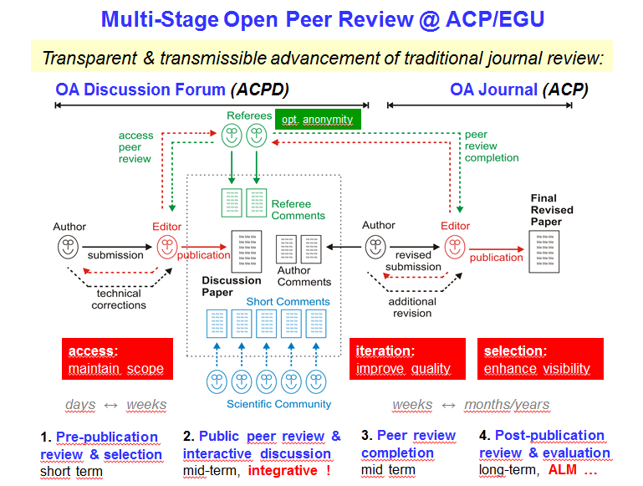

- The journal can now publish quickly and rejects few articles, while maintaining high impact and visibility.
- The journal is fully self-financed.
- Suggestions for the future include:
  - promoting further experimentation with peer review by building on existing models
  - demanding access to reviews and pre-publication history in order to raise standards and expectations
  - promoting article-level metrics rather than impact factor.

F1000Research
- Academic publishing is broken.
- Now is a time of rapid transformation – the culmination of 10 years of developments.
- Journals have not adapted in line with technology.
  - People rarely read entire journal articles any more and often do not read them in the original journal (printed or online).
  - Journals do many good things, such as commentary, blogs and opinion pieces, but are not fit for purpose in disseminating the findings of research.
  - Full transparency is essential for research publications.
- F1000Research aims to provide a solution based on several fundamental principles.
  - Researchers should be able to communicate all aspects of their research easily.These communications should be governed by rules and ethical guidelines.
  - Reviews must be open and transparent.
- The roles of a journal should be commentary, curation and quality assessment – a journal should not dictate what can and cannot be published.
- The pharmaceutical industry should adopt the Wellcome Open Research approach – or develop a similar approach.

Discussion

The need for change

Who are publications for?
- Trial participants are rarely informed of the outcomes of research.
- Power lies in the questions asked of data; the wrong questions asked by the wrong people result in bad or pointless research.
- Research ultimately aims to help patients, who need to be involved.

Researchers are rarely motivated to write up and publish negative results
- Industry-sponsored clinical research papers are typically authored by academics or clinicians.
- It can be hard for funders to know when the research they fund has been published.
    - Some withhold 10% of funding until all results are published.
    - Preprints may offer an alternative solution.
- Industry-sponsored clinical trial outcomes are already publicly hosted on sites such as ClinicalTrials.gov.

Data sharing
- If data are made publicly available, why publish at all?
    - Large data sets are not necessarily easily interpreted by patients or clinicians.
    - Publication records are still essential for researchers’ careers.
    - Sales and marketing materials must be supported by a peer-reviewed paper.
- If it is useful, data sets should be published – but who would use them?
- Regulations on communication are not intended to restrict transparency.
- Clinical trial reports are all available online for new studies, but few people want to read them.
- A unified platform collating all linked research outputs could increase usage and facilitate access to these data.

Quality assessment
- High-tier journals publish based on citability, not quality.
- Patient experience and individual outcomes are not part of the evaluation of research outputs.
- As soon as impact factor drops, submissions drop too, which is a big problem.
- Impact factor is hard to replace while research careers depend on publication history.

Needs of the pharmaceutical industry

Is paid-for open access considered promotional?
- Open access publication costs are not generally considered inherently promotional.
    - Companies differ in their views and some still have reservations.
    - Companies should not cherry-pick which articles are made open access.
- Clear guidelines for pharmaceutical companies using publishing innovations are not available, but this is a solvable problem.

There are issues of trust surrounding pharmaceutical research
- The value of industry-sponsored research can be lost because it is not always trusted, even when it is of high quality.
- Should pharmaceutical companies be allowed to fund only non-clinical research?
    - Clinical research is already subject to more regulation and transparency requirements than preclinical and observational research.

How do pharmaceutical companies determine who they work with and how they publish research?
- External authors (academics and clinicians) are selected by pharmaceutical companies for their capacity to run clinical trials efficiently and to report the findings thoroughly, to budget and on schedule.
- Research centre reputations are also considered.
- Authors choose where to publish.
    - Competition for the best external collaborators could discourage companies from adopting open access policies, particularly if hybrid journals are disallowed.
    - Cross-company initiatives may be the best approach.
    - Impact factor is less important to industry employees than to external academics and clinicians.

The future

Where do we see publishing in 10 years’ time?
- Open access will be far more prevalent.
- The subscription model will have eroded.
- Research volume will remain a big issue.

What needs to be done to enhance the rate of change?
- An evidence-based case for change is needed.
  - Data showing the problems with Peer review.
  - Evidence showing examples and prevalence of Publication bias.
  - Measurements of the harm to patients from the above issues.

Potential actions for pharmaceutical companies
- Formulate a public open access policy (to be undertaken by a group of pharmaceutical companies).
- Develop a preprint mandate.
- Promote ORCID (Open Researcher and Contributor ID) to authors of industry-sponsored research.
- Establish industry publishing platforms.
  - Break down the results into various outputs to cater to the needs of each stakeholder (e.g. patients, payers, clinicians, academics).
  - Centralize all outputs and documents linking to a piece of research on this platform.
- Embark on an education initiative for industry.
  - Few companies see improving publishing as their responsibility.
  - If compliance concerns are assuaged, industry may become more involved.
  - Regulators exist to prevent bad practice, not to impede scientific discourse.
  - Communication could take place through existing initiatives.
- Develop four distinct workstreams to promote the use of each of the following innovations within the pharmaceutical industry:
  - open access
  - ORCID and CONVEY
  - preprints and post-publication peer review
  - multilevel, integrated funder provided publishing platforms.

Participants
Present
Chair: Richard Smith (Chair, Patients Know Best; Chair of the Board of Trustees, International Centre for Diarrhoeal Disease Research, Bangladesh; former Editor, British Medical Journal)
Jodi Cusack (Project Manager, Oxford PharmaGenesis)
Deborah Dixon (Global Editorial Director, Medicine & Science Journals, Oxford University Press)
Juan García Burgos (Head of Medical and Health Information, European Medicines Agency)
Fiona Godlee (Editor-in-Chief, British Medical Journal)
Robert Kiley (Head of Digital Services, Wellcome Trust)
Tim Koder (Communications Director, Oxford PharmaGenesis)
Azeem Majeed (Professor of Primary Care, Imperial College London)
Erik Michels (Director and Head of Scientific Public Disclosure and Literature Intelligence, UCB)
LaVerne A Mooney (Director and Team Leader, External Medical Communications, Publications Management, Pfizer)
June Raine (Director of Vigilance and Risk Management of Medicines, Medicines and Healthcare products Regulatory Agency)
Chris Rains (Vice President, Global Medical Affairs, Shire Pharmaceuticals)
Rosamund Snow (Patient Editor, British Medical Journal)
Stuart Taylor (Publishing Director, The Royal Society)
Katherine Tucker (Senior Manager, Patient-level Data Sharing, Roche)
Vitek Tracz (Chairman, Science Navigation Group; Founder, F1000Research)
Christine Vanderlinden (Director and Head of Publications Management, Vaccines Office of Medical Governance and Bioethics, GSK Vaccines)
Elizabeth Wager (Publications Consultant; Co-Editor-in-Chief, Research Integrity and Peer Review)
Al Weigel (President, International Society for Medical Publication Professionals)
Amy Williams (Project Coordinator, Oxford PharmaGenesis)
Chris Winchester (Managing Director, Oxford PharmaGenesis; Honorary Associate of the School of Medicine, Pharmacy and Health, Durham University)

Pre-recorded video presentation
Ulrich Pöschl (Editor, Atmospheric Chemistry and Physics)

Apologies
Carl Heneghan (Professor of Evidence-Based Medicine, University of Oxford)
Ken Stein (Professor in Public Health, University of Exeter)

Since the meeting, the Gates foundation has also announced that it will be setting up a similar platform

